MACH4METAL

metalworking machinery
Transito 21,
6909 DA BABBERICH
Netherlands
Tel. +31 (0)316 – 247123
Fax. +31 (0)316 - 247956
info@mach4metal.com
www.mach4metal.com

Bank No : 66.52.13.883
IBAN : NL33 INGB 0665 2138 83
BIC : INGBNL2A

TIG MIG LINCOLN Welding machine
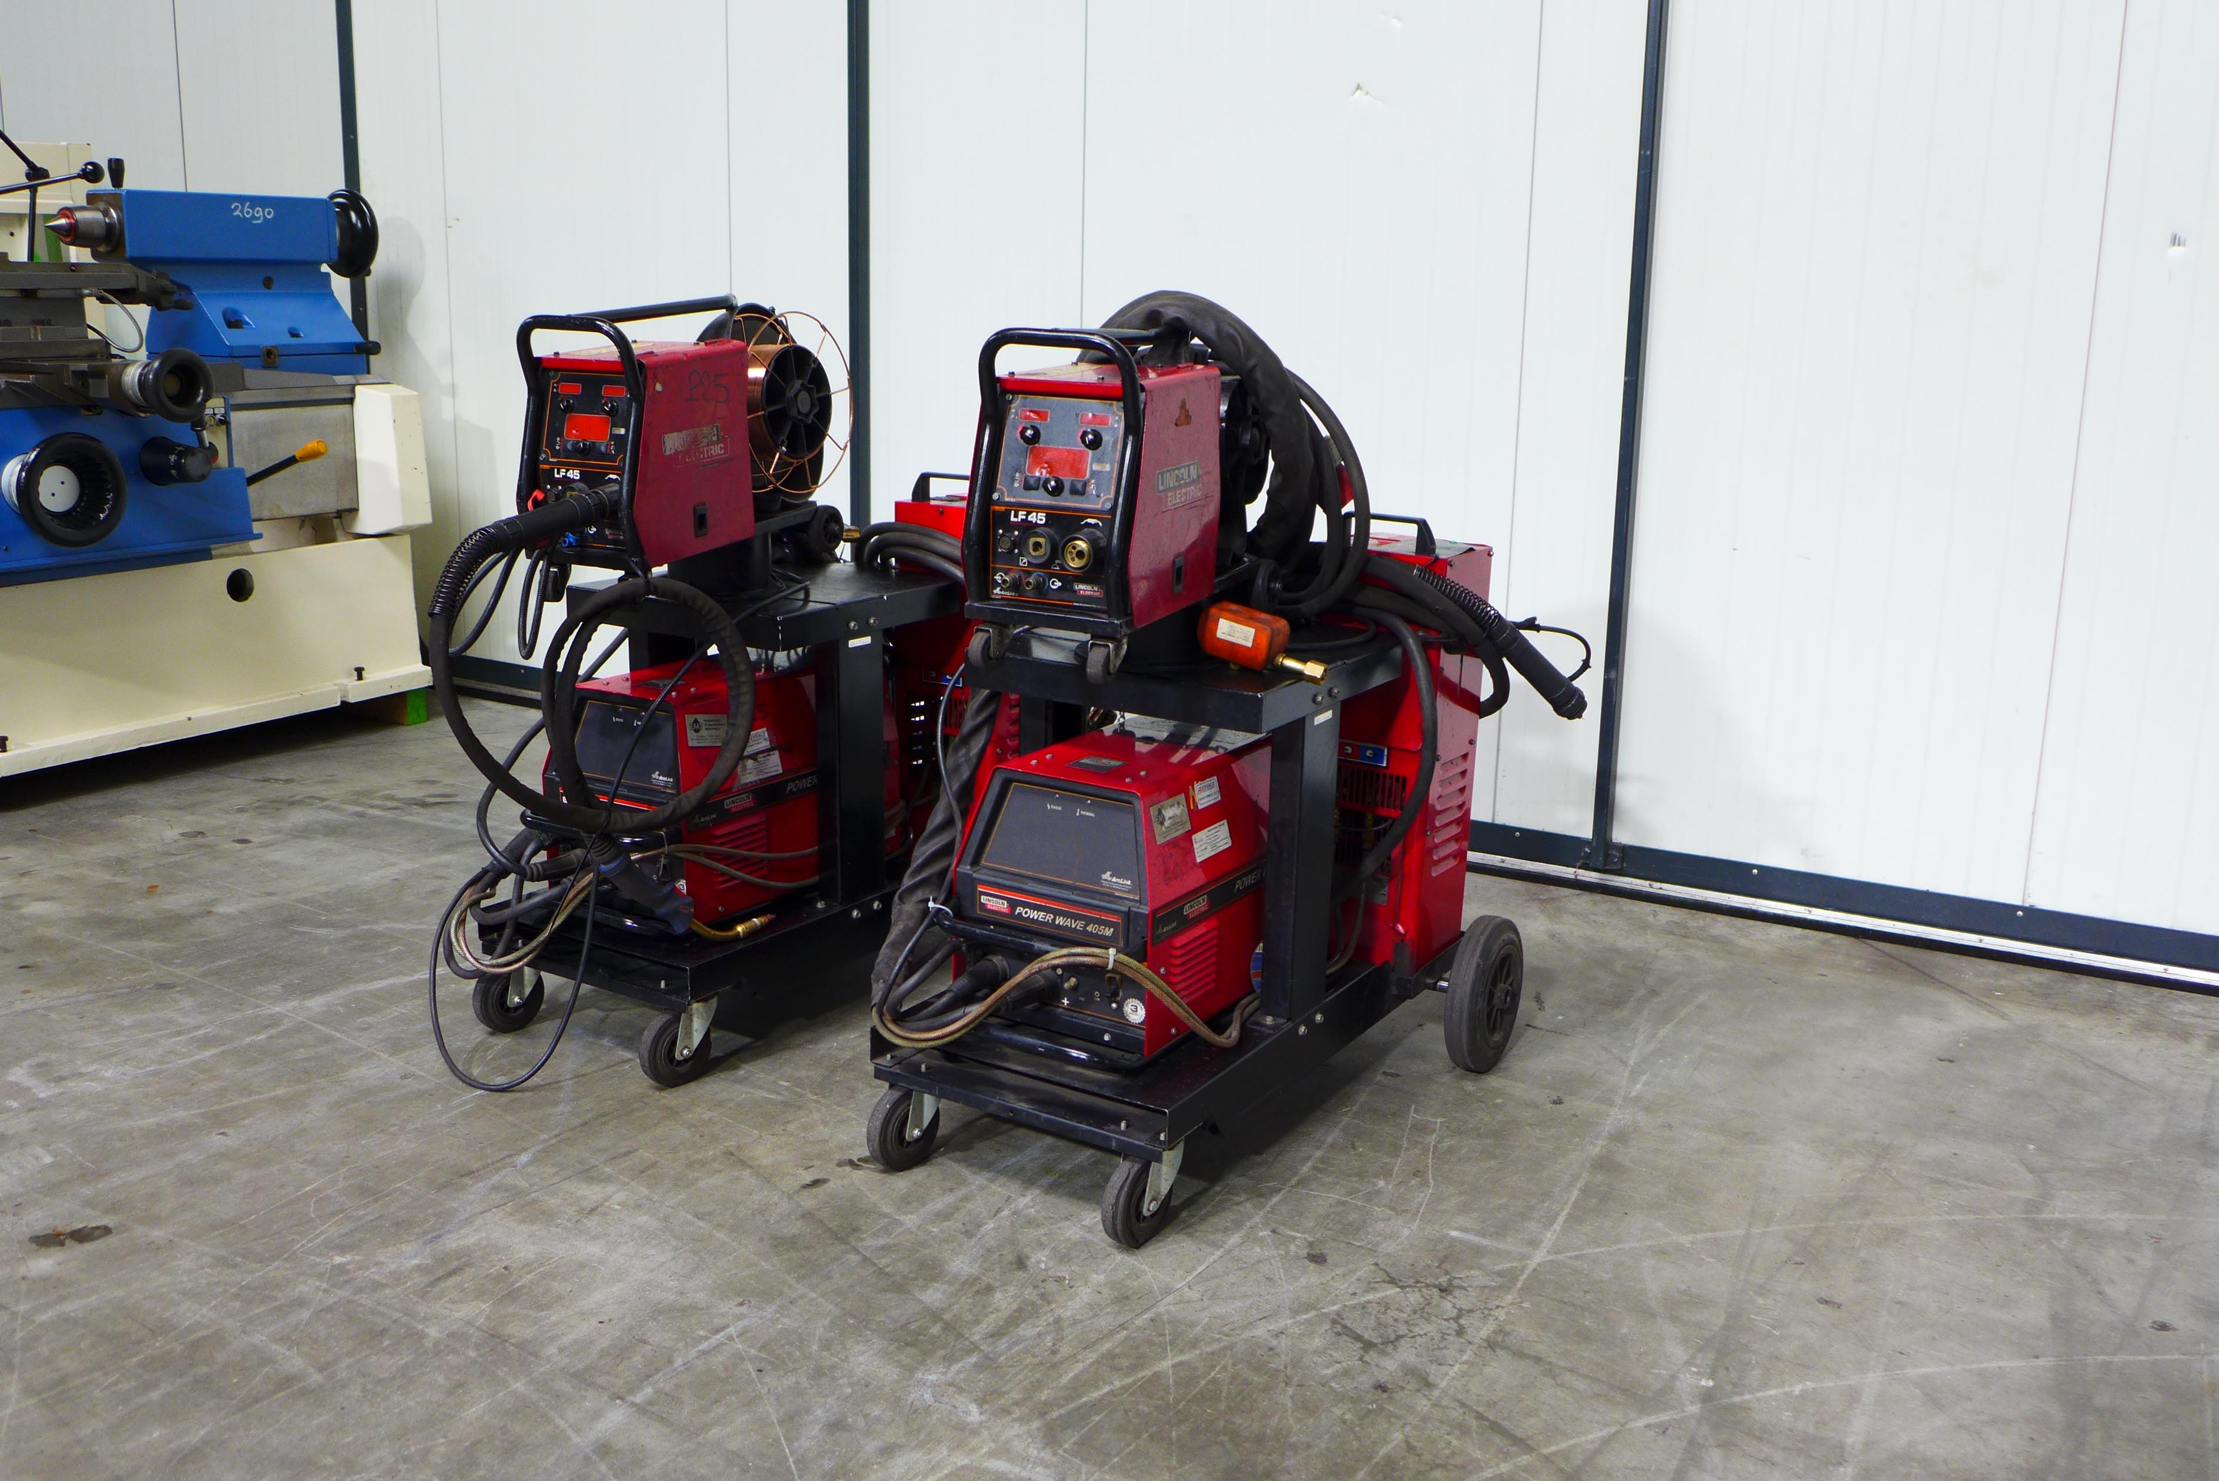
- Make : Lincoln ELECTRIC
- Typ : Power wave 405 M
- Mach.No : U 1100 308218
- Age :

- Output range
- Rated power 60 % : 320 A
- Rated power 100 % : 300 A

- Imput 20 – 385 A
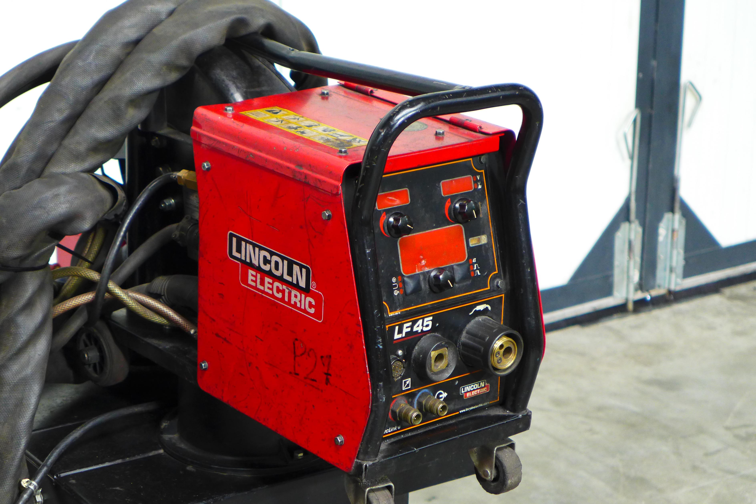
- Tension 34 V

- Number off programs : 99
- Wire Ø : 0,8 – 1,6 mm
- Incl. separate feeder box

- Dimensions
- Length : 400
- Width : 400
- Height : 800
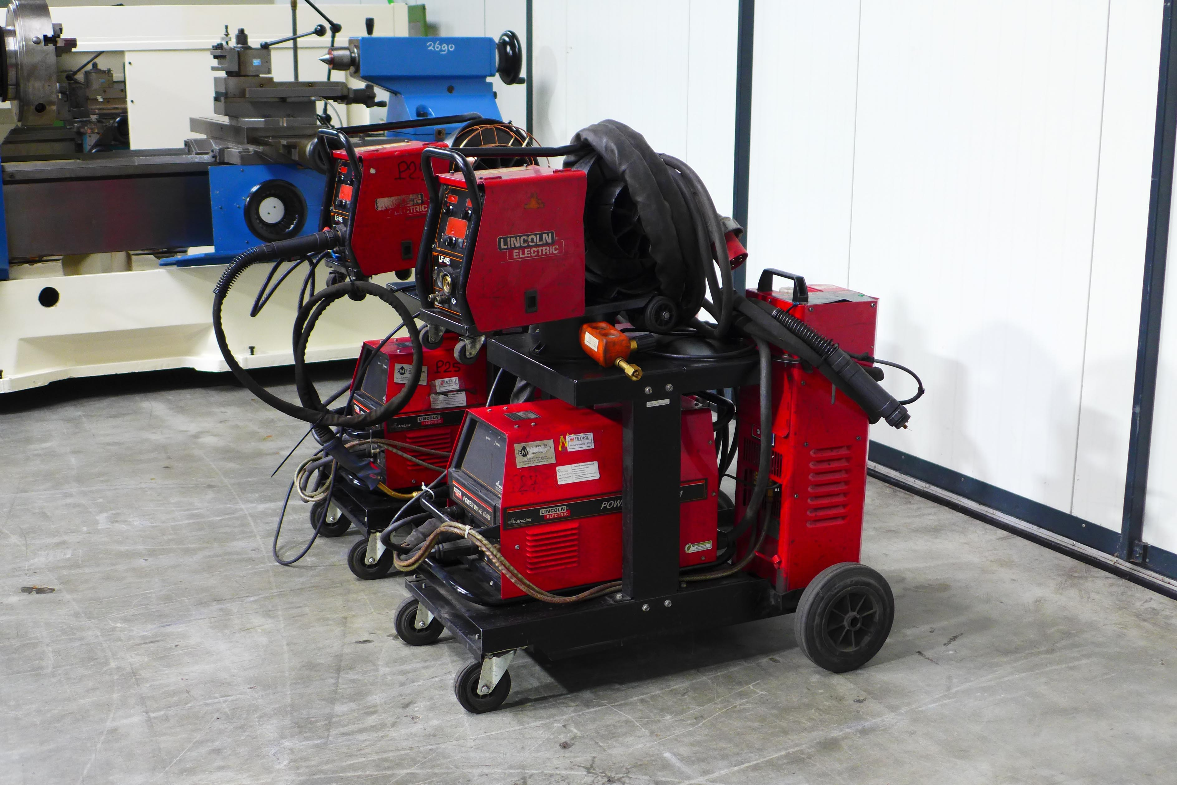
- Weight : 37 Kg

- Incl. Lincoln LF 45 feeder
- Incl. Lincoln cool arc TM 25
- Incl. Lincoln mobile transport trolley

Please Note: The above information has been obtained to the best of our ability and belief from, and from the manufacturers where possible. It is given in good faith, but its accuracy can not be guaranteed. Accordingly, it will not form a representation or constitute contractual terms. We advise you to check any vital details!

